# Interior Design Foundation: Design Response & Development

## Transforming Client Briefs into Design Solutions

What sets professional interior designers apart is their knack for turning client requirements into practical, thoughtful design solutions. This systematic approach will give you confidence when facing design challenges as you begin your interior design journey.

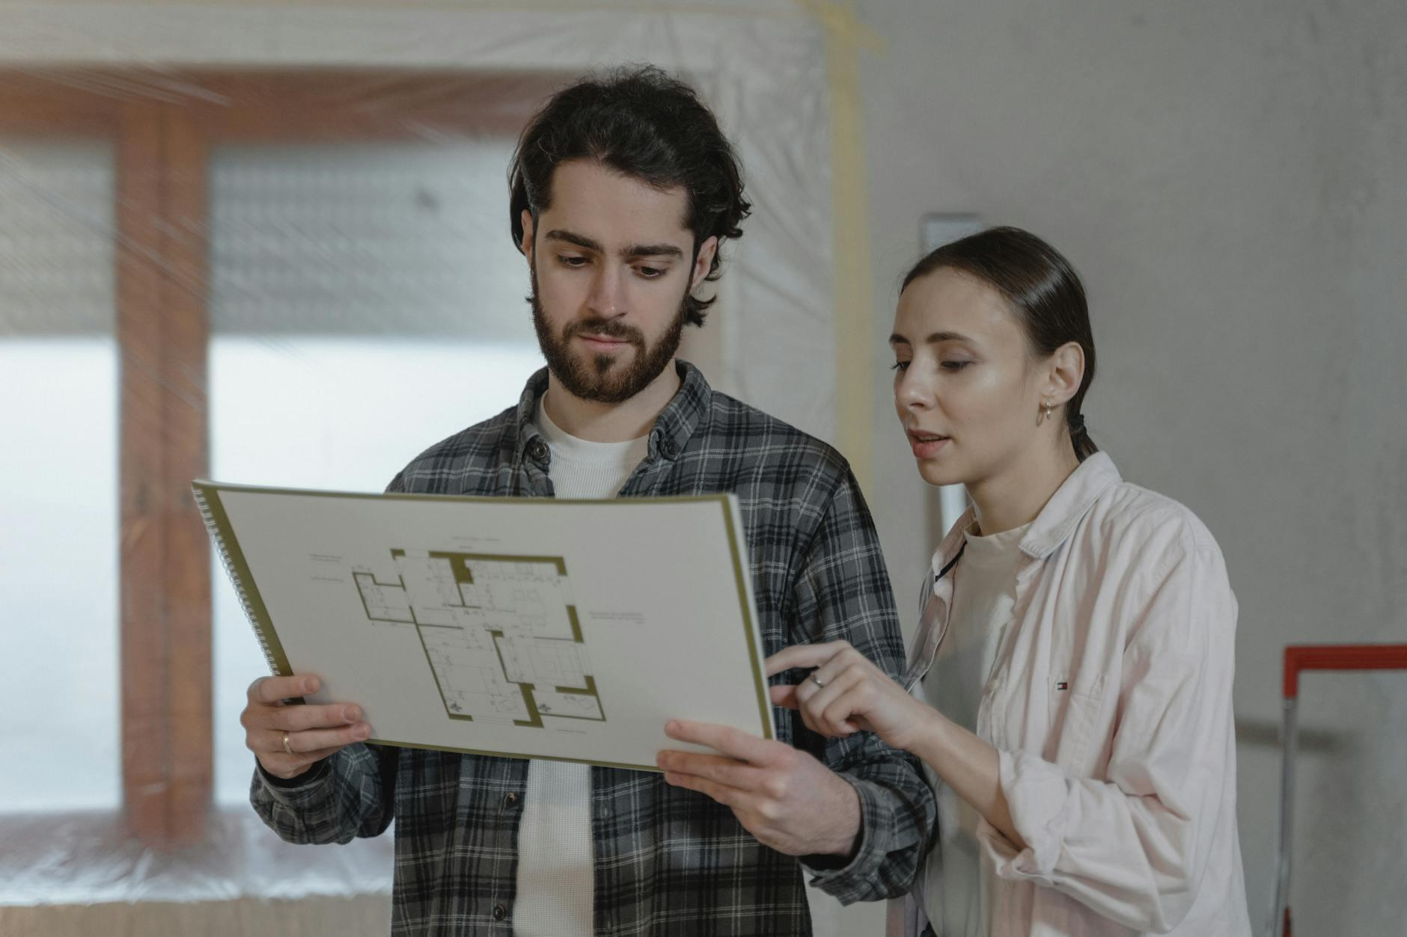

Fig.1 (Tima Miroshnichenko on [Pexels](https://www.pexels.com/photo/6474498/), 2025) The collaborative process between designer and client forms the foundation of successful interior design projects

## 1. The Systematic Design Process

Professional interior design isn't about random flashes of inspiration—it follows a structured approach that yields consistent, quality results regardless of project complexity.

### The Design Journey:

Picture the design process as a path you'll travel with every project. While experienced designers might make it seem effortless, they're actually following steps they've refined through countless projects. Here's how we can break this journey into manageable segments that will help you tackle your first design challenges:

1. **Research & Analysis**: Building on the documentation techniques from Lesson 1

* Focusing on design-specific information gathering
* Translating client needs into design parameters
* Understanding that the client brief guides all design decisions

1. **Concept Development**: Exploring multiple potential solutions

* Creating 2-3 distinct approaches rather than running with your first idea
* Using bubble diagrams to map spatial relationships (simple circles showing connections between spaces)
* Sketching rough ideas to visualize different possibilities

1. **Refinement**: Developing the chosen direction with greater detail

* Basic space planning with essential measurements
* Initial thoughts on materials and finishes
* Identifying furniture and fixture requirements

1. **Presentation**: Building on presentation techniques from Lesson 2

* Concentrating on design-specific communication
* Demonstrating how your solution addresses the client brief

**Note:** While I've presented this sequentially, design actually works in cycles. You'll frequently loop back to earlier stages as you refine your ideas.

**Over to You** Select a simple space (perhaps a bedroom or home office) and sketch two different layout concepts. For each, write a brief explanation of how it meets key functional requirements. This exercise will help you become comfortable generating multiple solutions rather than settling for your initial idea.

## 2. Development Approach: From Concept to Reality

After sketching initial concepts, you'll need to develop them into more detailed designs.

### Space Planning Fundamentals

When you enter a well-designed room, it feels natural and intuitive - but this doesn't happen by accident. Good space planning creates this feeling through thoughtful organisation. As your concepts take shape, focus on these key principles:

* Establishing activity zones based on function (grouping similar activities together)
* Plotting primary circulation paths (main walkways)
* Ensuring basic furniture clearances (making sure there's enough room to move around)

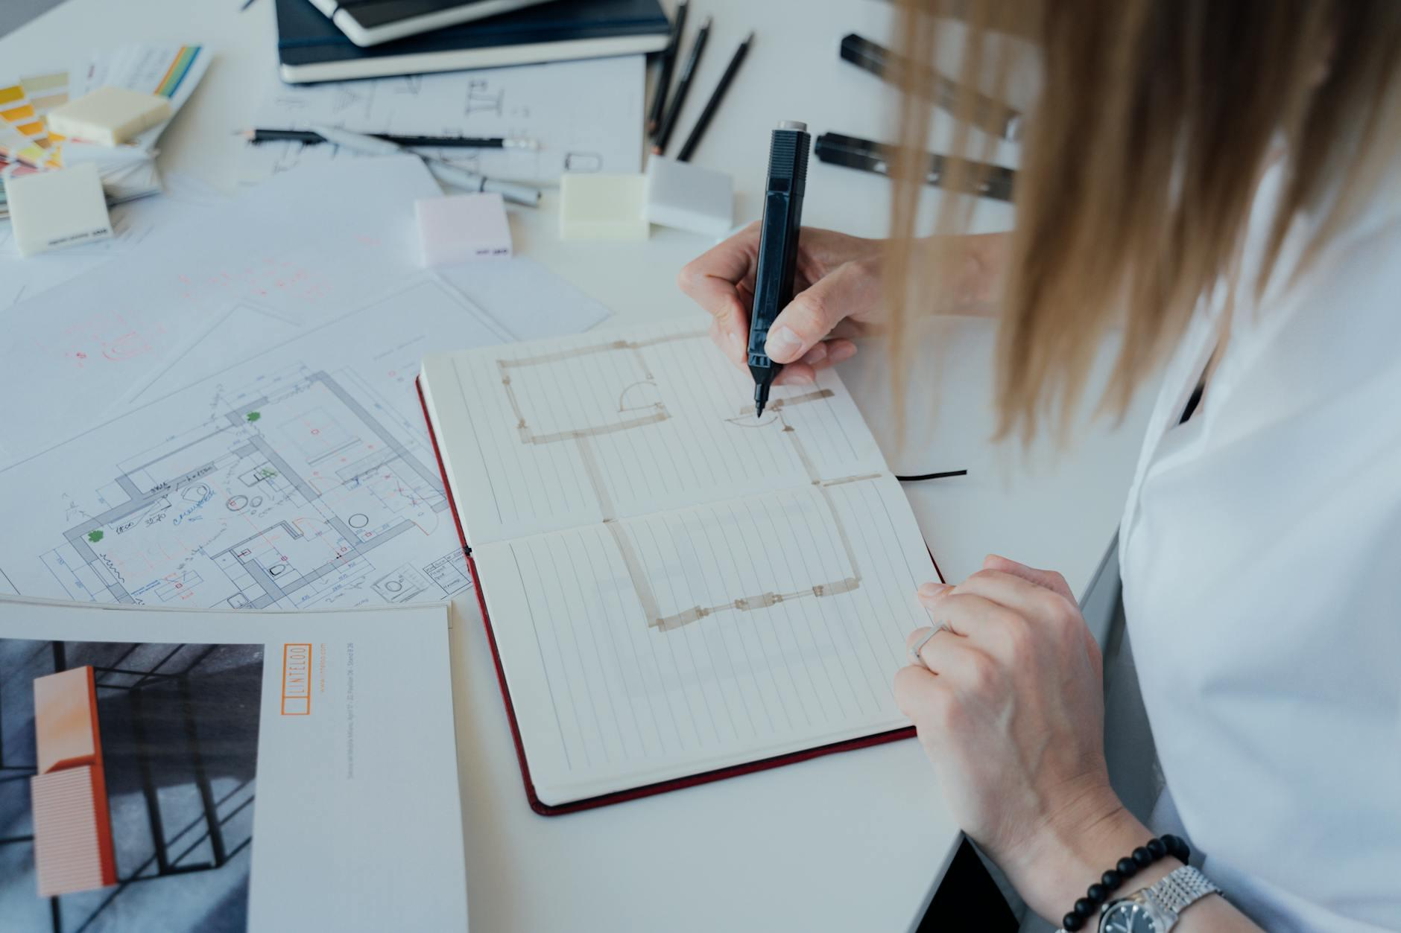

Fig.2 (Antoni Shkraba on [Pexels](https://www.pexels.com/photo/5292237/), 2025) Effective space planning creates intuitive flow and functional zones while maintaining proper clearances

### Material Selection in the Design Process

Materials act as supporting characters in your design story - they enhance the narrative without stealing the spotlight. When choosing materials:

Start with function first - a stunning marble might look gorgeous for a kitchen worktop, but won't be practical if your client regularly cooks with acidic ingredients.

Consider the emotional impact - materials create both visual and tactile experiences that significantly affect how people feel in a space.

Remember that material choices should reinforce your overall concept rather than clashing with it or feeling disconnected.

*Common Mistake*: Many beginners choose materials based solely on aesthetics before completing their space planning. This typically leads to impractical designs or budget nightmares later on.

### Concept Progression Techniques

As your design evolves from rough idea to polished concept, you'll need ways to capture and communicate this journey:

**Visual storytelling tools:** Create simple mood boards showing general inspiration that capture the atmosphere you're aiming for. Sketch your basic ideas - these don't need to be perfect, just clear enough to convey your thinking.

**Technical development:** Draw basic space plans showing furniture arrangement to test how the space functions. Gather material samples showing key selections to see how colours and textures work together.



Fig.3 (ANTONI SHKRABA production on [Pexels](https://www.pexels.com/photo/8837623/), 2025) The design development process moves from initial sketches to refined concepts with material selections

## 3. Design-Specific Quality Control

Before presenting your design to a client, you need to step back and evaluate your work objectively. This quality assessment helps identify potential issues before they become problems during implementation. Just as writers edit their work, designers need to review their solutions critically.

Before finalising your design concept, ask yourself these design-specific review questions:

**Over to You** Visit a café, restaurant, or public space that feels well-designed. Make notes on how the space is organised, what materials they've used, and how people move through it. What elements suggest the designer followed a methodical process? How might you apply similar thinking to your own projects?

## Equipping You for HNC Success

The methodical design approach and analytical skills you've developed form the foundation for tackling more complex client briefs and spatial challenges you'll encounter throughout your HNC qualification.